Global GUI designs module F

Team S61E

Contents

Introduction 3

The GUI model 4

Lay-out standard 5

Screen designs: Before competition 6

Screen designs: During competition 7

0.1 Homepage 7

1.1 Scores 9

1.2 Teams 10

1.3 Newsfeed 11

1.4 Rounds 12

1.5 Assignment 13

1.6 Competition 14

Screen designs: After competition 15

# Introduction

This document contains screen designs for module F and a GUI module to show how a user can navigate through the different web pages of the application.

Module F is an HTML client and is meant to display information about the current competition, such as the participating teams, scores and the newsfeed. Users can also take a look at the scores of previous competitions. Unlike module D, this HTML client is meant for non-participants.

The sole purpose of the following designs is to show the lay-out and functionality of the application; specific details, such as color schemes and images, have not been included.

# The GUI model

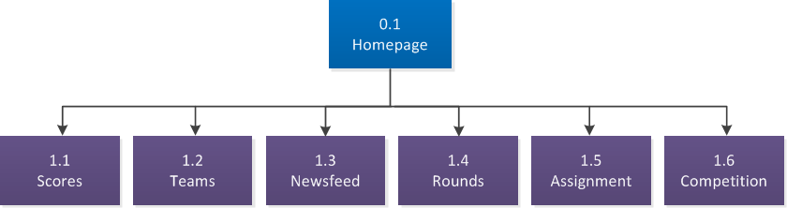

The GUI model for module F is quite simple. There’s a homepage and six subpages to navigate to:

* Scores: this page shows a ranking of teams and scores for a competition.
* Teams: shows information about the teams that are participating in the competition, including the name of the team members and the team’s current score.
* Newsfeed: contains messages about the activities of each team, such as turning in an assignment or executing a user test. The results of compilations and test will not be shown.
* Rounds: this page shows an overview of the rounds assigned to the current competition, as well as the status and how many time is left until the end of each round.
* Assignment: general information about the assignment, such as the author and a description of the assignment, can be found here.
* Competition: general information about the competition, such as the company and a description of the competition, can be found here.

Regardless of the page the user is visiting, it’s always possible to navigate directly to any of the other pages thanks to a menu bar at the top of the screen.



# Lay-out standard

In the following chapters the content of each screen is described. This lay-out standard describes what the entire page looks like.

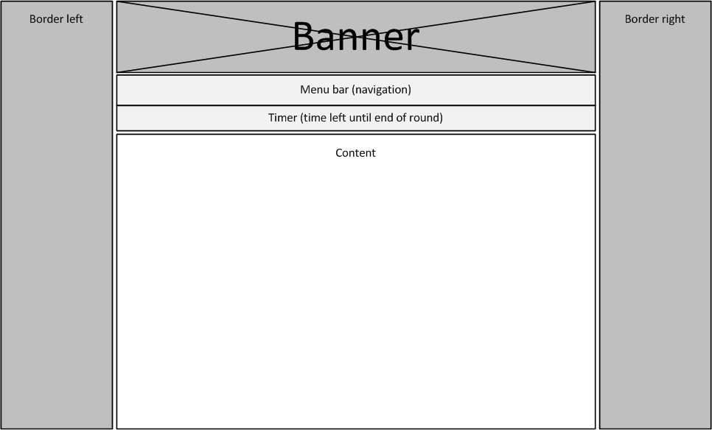

# Screen designs: Before competition

Before the competition has started, there is only one page that the user can visit. This is a simplified version of the homepage that the user gets to see during the competition. There is no menu bar or separate timer on this web page.

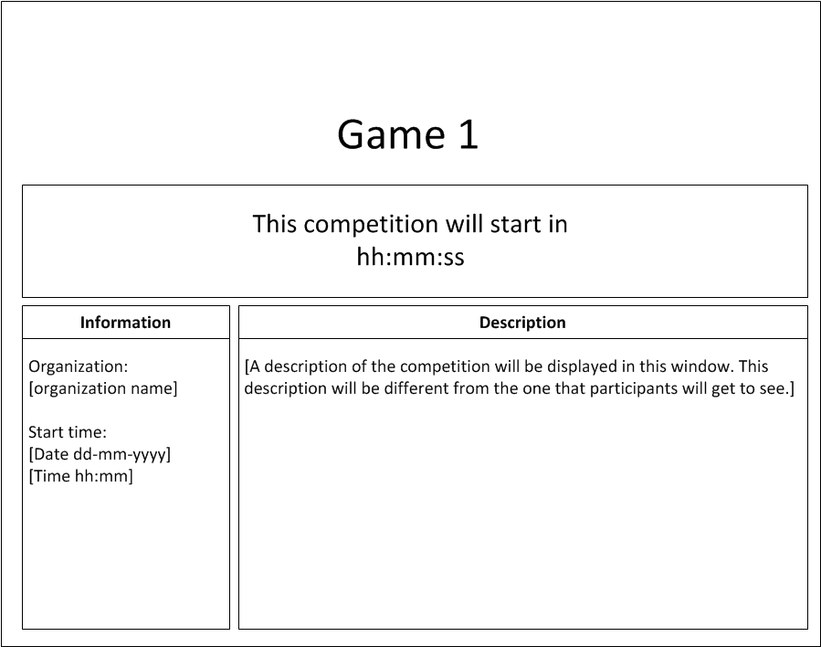

On this page, users can view information about the competition. There’s also a timer that shows how much time is left before the start of the competition. It isn’t possible to view information about the rounds or teams yet.

# Screen designs: During competition

## 0.1 Homepage

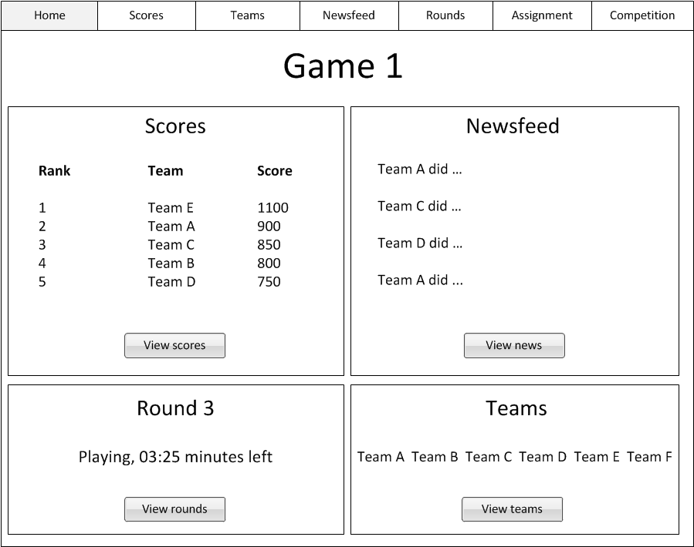

The homepage is the first page that is displayed when visiting the HTML client. It shows a brief summary of the information about the current competition. The user can either choose to navigate to other pages by using the menu bar or clicking on one of the buttons in the different panels.

### 0.1.1 Scores

The recent scores section contains a list of top scores of the current competition. This is the current score of the x best teams during the competition (in this case, the scores of five teams are shown).

### 0.1.2 Newsfeed

The newsfeed section displays the most recent activities of the participating teams. If there are no news messages, the client will display a message ‘There’s no news yet.’ in the recent scores section.

### 0.1.3 Round

This section displays the number and status of the round that is currently playing. It also shows how much time is left before the current round ends.

### 0.1.4 Teams

There’s one more section on the homepage, which is the teams section. It’s simply a list of teams participating in the competition. Since the number of teams participating in a competition may vary, only the first few teams will be listed.

## 1.1 Scores

The scores page has two buttons to switch between sections. A user can view the most recent scores of the current competition or view the final scores of one of the previous competitions.

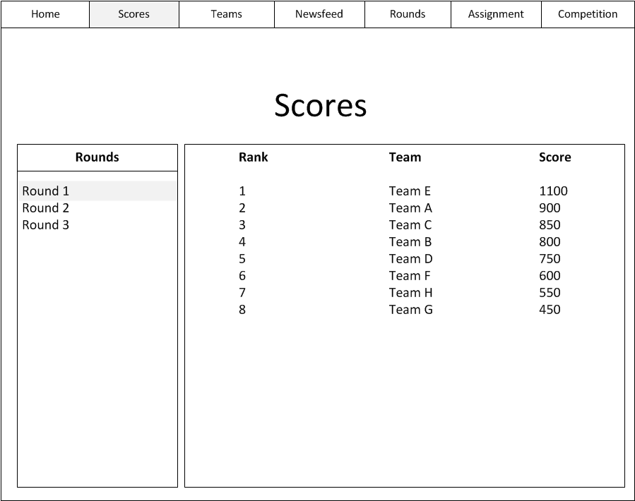

In this section, a list with current scores is displayed. The team will also be ranked based on their current score. In the screen design, there are eight teams, but the number of teams might be different for each competition.

The user can use the items in the listbox to view the scores of the rounds that have already ended and the round that is currently playing or paused. The rounds that haven’t started yet will not be selectable.

## 1.2 Teams

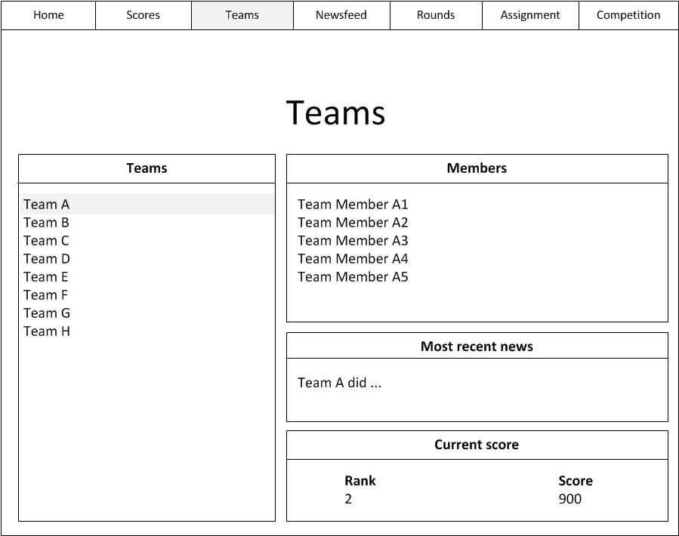

On the teams page, the user can get information about the teams that are participating in the current competition. These teams are listed in the listbox on the left side of the page.

Upon selecting one of the teams, the three sections on the right side of the page will be filled with the following information:

* The ‘Members’ section shows the names of the team members. The initiator of the team will be the first member on the list.
* ‘Most recent news’ displays the latest activity of the selected team.
* The ‘Current score’ section displays the current rank and score of the team.

## 1.3 Newsfeed

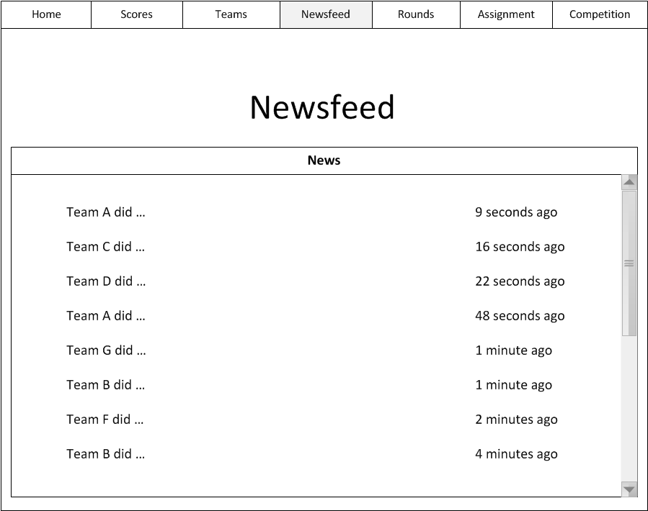

The newsfeed page shows a list of all activities from all of the teams. This includes compiling, executing tests and turning in an assignment. However, the results of compilations and tests aren’t shown.

## 1.4 Rounds

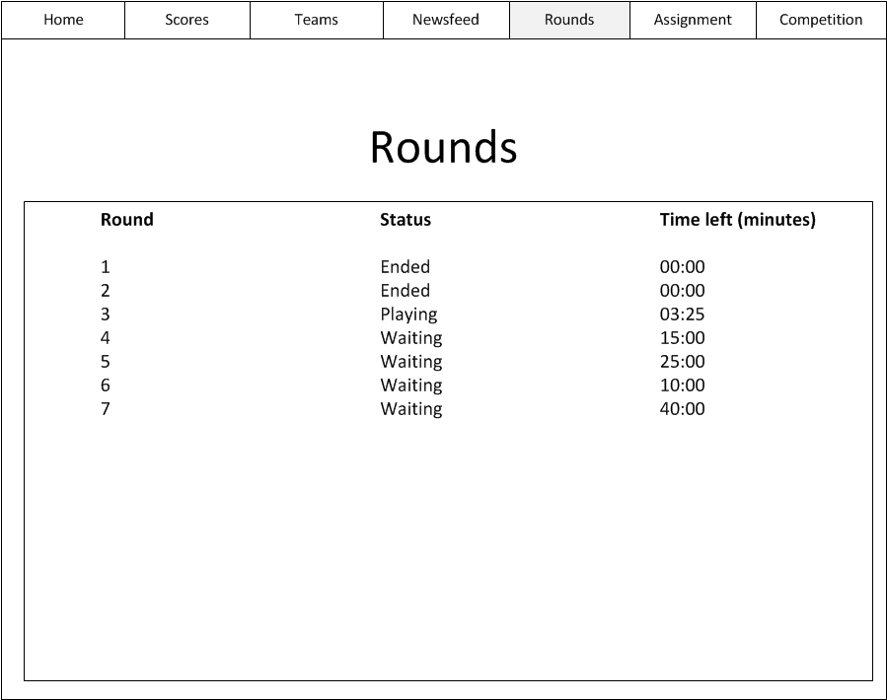

One of the web pages of this application is the rounds page. Here, the user can get an overview of the different rounds of the competition and the status and duration of each round. There are four different statuses for a round: waiting, playing, paused and ended.

When the status of a round is set to ‘waiting’, it means that the round hasn’t been started yet. In that case, the value in the ‘time left’ column will be the total duration of that round (e.g. 40 minutes).

## 1.5 Assignment

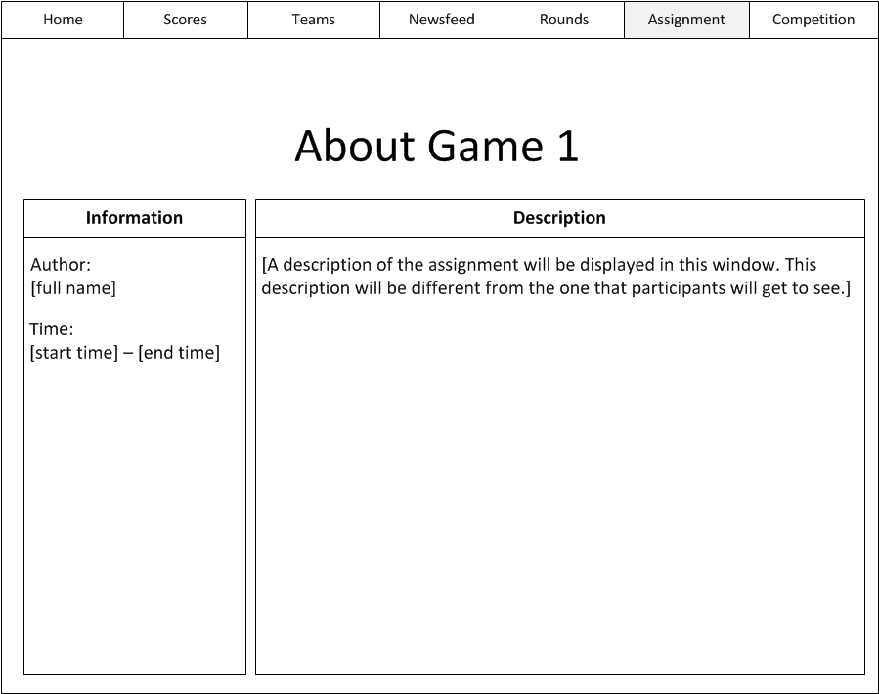

This is a page with information about the assignment. There are two sections on this page.

### 1.5.1 Information

The left section of the ‘About’ page contains a couple of small details about the competition’s assignment, such as the name of the author who created the assignment and the start and end time of the assignment. The start time consists of both the date and the time.

### 1.5.2 Description

The ‘Description’ section, the right section of the page, shows the description for spectators. This is one of the descriptions that the author filled in while creating the assignment. The description for participants cannot be accessed through this web application.

## 1.6 Competition

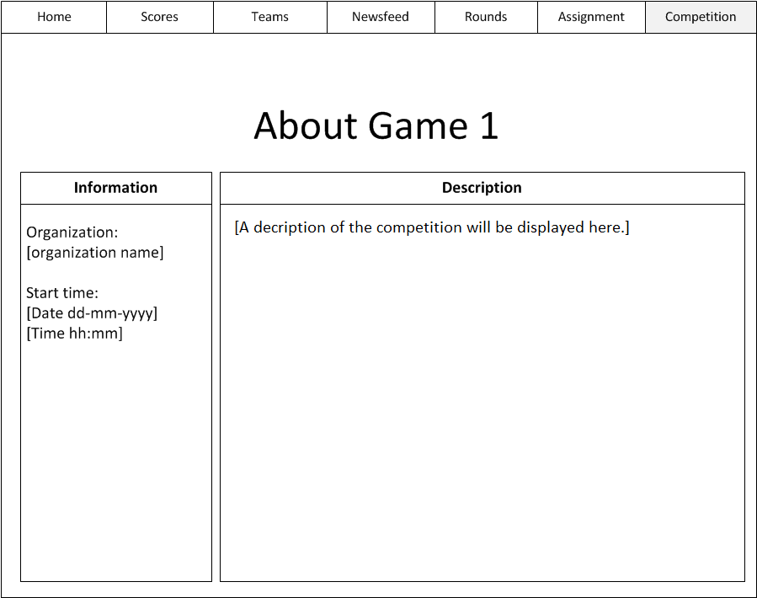

Just like the assignment page, the ‘Competition’ page is divided in two sections.

### 1.6.1 Information

The left section of the ‘About’ page contains a couple of small details about the competition, such as the name of the organization and the start time of the competition. The start time consists of both the date and the time.

### 1.6.2 Description

The ‘Description’ section, the right section of the page, shows the description for spectators. This is a global description of the entire competition. The description for participants cannot be accessed through this web application.

# Screen designs: After competition

Once the competition has ended, there is only one page that the user can visit. This is a simplified version of the homepage that the user gets to see during the competition. There is no menu bar or separate timer on this web page.

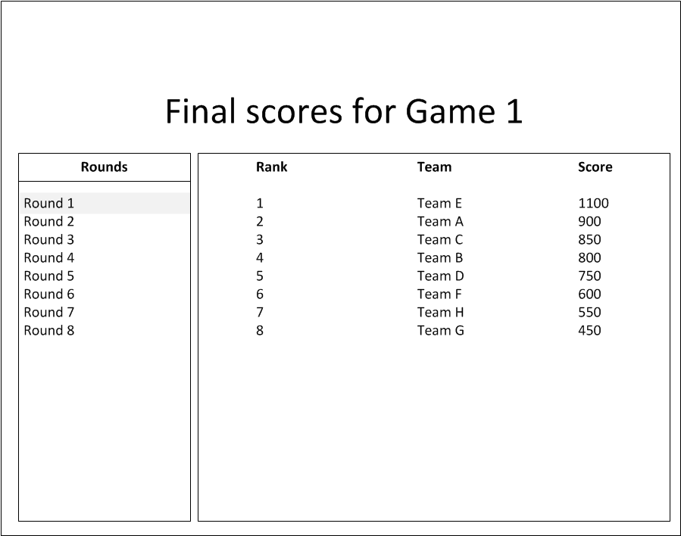

At the end of the competition, the user can view all of the scores of each team. It’s practically the same as the ‘Scores’ page that users can navigate to during a competition.